CS670 Project Doc

Sentimental Analysis:

Required modules added as requirements.txt read by huggingFace:

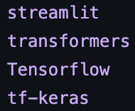

Starting with the imports:

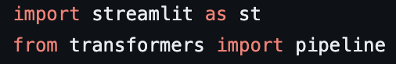

Title and input field of the app:

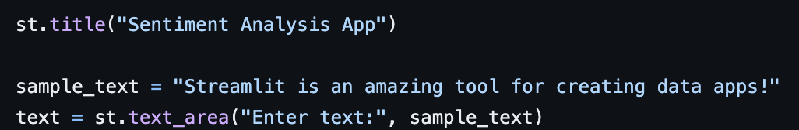

Pretrained model used:



Classifier and result:

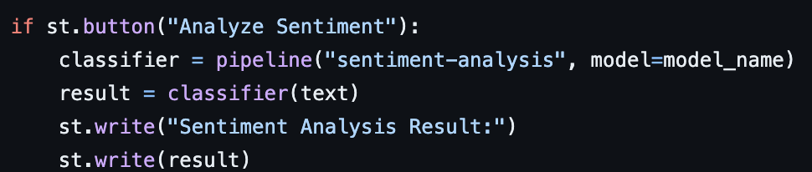

Sentimental Analysis Result:

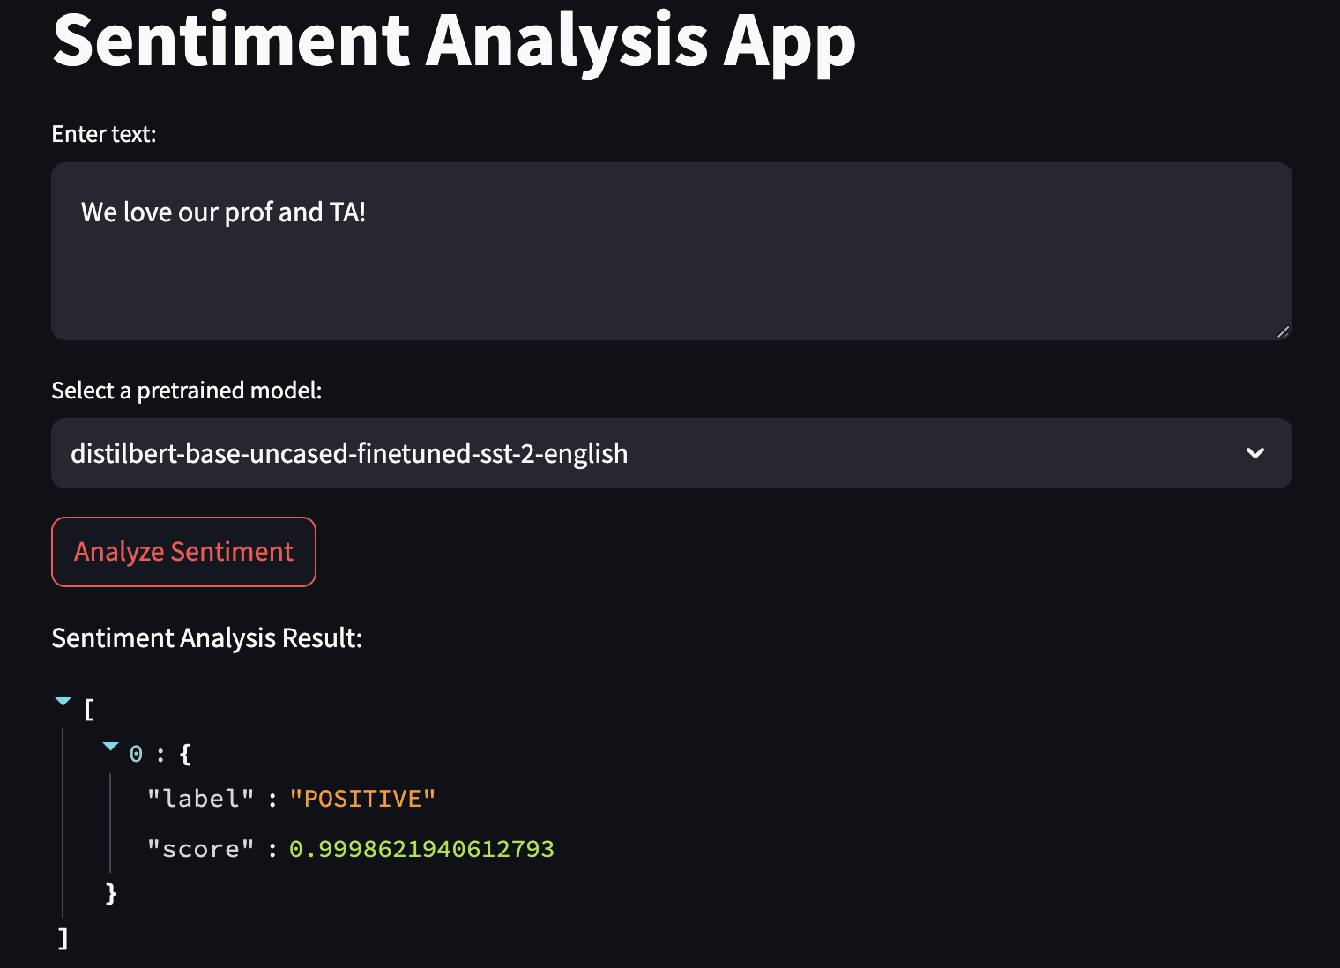

USPTO App:

Required modules added as requirements.txt read by huggingFace:

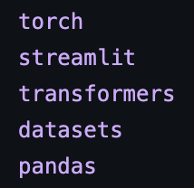

HuggingFace custom built model to increase the accuracy

Also tried taking larger data for better training, but was taking very long to execute so switched back to original suggested dataset Jan 2016 files

Imports:

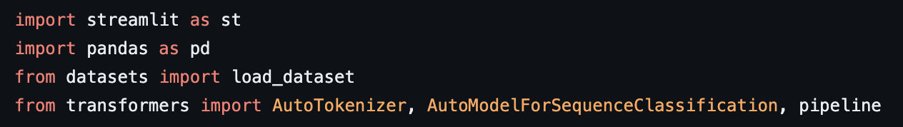

Load the train model from huggingFace and tokenizer

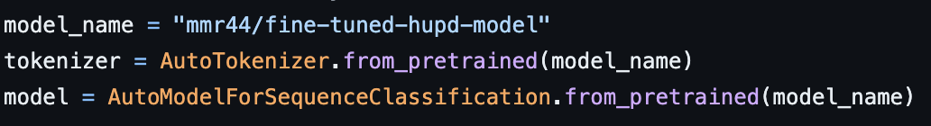

Create pipeline:



Load dataset:

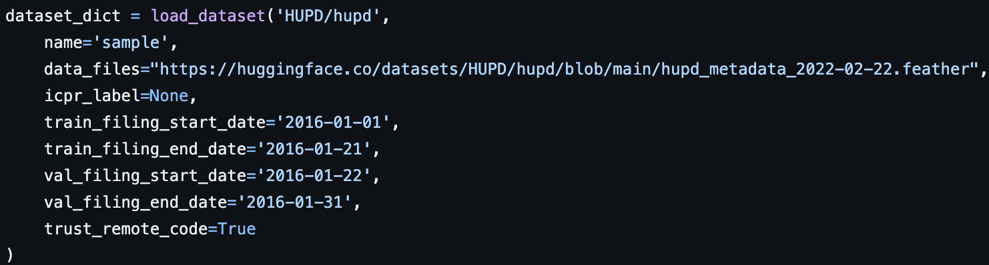

Get unique patent number from dataset:

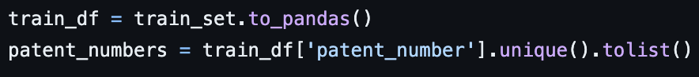

App side title and dropdown with all patent file numbers:

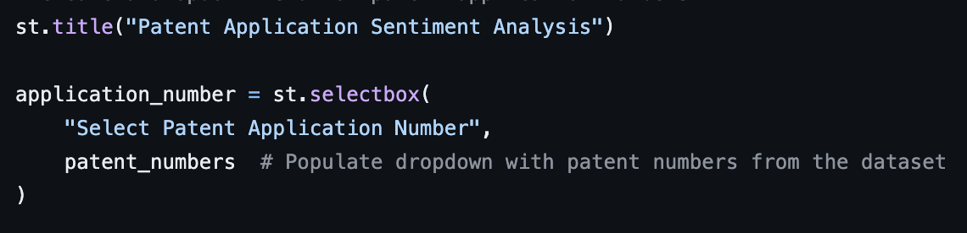

Show abstract and claim of selected patent file from dropdown:

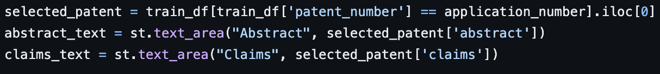

Truncate function:



Analysis and patent score output:

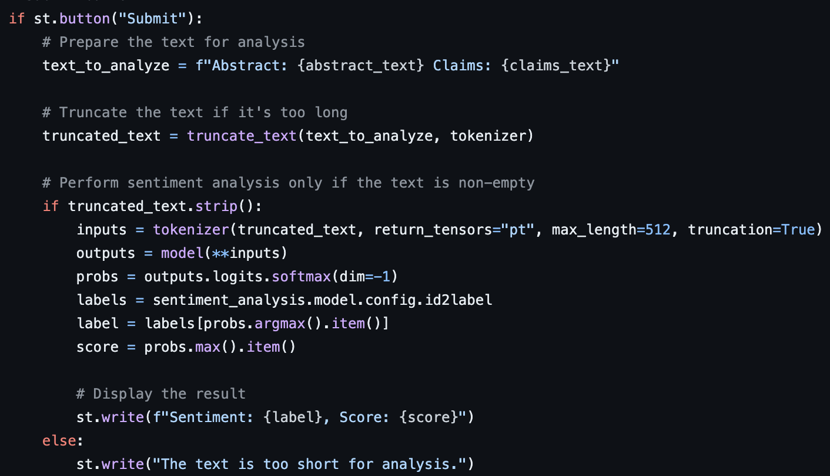

USPTO App result:

